DATA ANALYTICS PROJECT
Summary:
This project analyzes transactional data from a UK-based online retail business to understand overall sales performance, customer behavior, product performance, geographic concentration, and order cancellations. I cleaned and prepared the transaction data, engineered analysis-ready fields, used SQL to calculate key performance metrics and identify trends, and developed a Power BI dashboard to communicate the findings. The analysis focuses on revenue, orders, customers, products, geography, and cancellations to provide a clear view of what is happening in the business and where notable patterns or potential problems appear.

Industry/About the dataset
This is a transactional data set which contains all the transactions occurring between 01/12/2010 and 09/12/2011 for a UK-based and registered non-store online retail. The company mainly sells unique all-occasion gifts. Many customers of the company are wholesalers.

Variables Table
Variable Name | Role | Type | Description
InvoiceNo | ID | Categorical | a 6-digit integral number uniquely assigned to each transaction. If this code starts with letter 'c', it indicates a cancellation
StockCode | ID | Categorical | a 5-digit integral number uniquely assigned to each distinct product. There are also stock code in different formant and they are non-merchandise, when it starts with  D- Discount in the transactions, M-Manual , S – Samples, B- Adjust Bad Depth, C2- Carriage, Dot-Dotcom Postage, Post – Postage…….
Description | Feature | Categorical | product name
Quantity | Feature | Integer | the quantities of each product (item) per transaction
InvoiceDate | Feature | Date | the day and time when each transaction was generated
UnitPrice | Feature | Continuous | product price per unit
CustomerID | Feature | Categorical | a 5-digit integral number uniquely assigned to each customer
Country | Feature | Categorical | the name of the country where each customer resides

Data Cleaning Process
- Standardized descriptive columns such as Description and Country to ensure consistent formatting and reduce inconsistencies in categorical values.
- Validated numerical and categorical fields and ensured that each column was assigned the appropriate data type for analysis.
- Identified non-merchandise transaction codes in the StockCode column and created a derived is_merchandise field to distinguish merchandise transactions from non-merchandise entries.
- Converted InvoiceDate to a Date/Time format to support accurate time-based analysis.

Feature Engineering
- is_merchandise column: some of the stock codes are not sold products, they are non-merchandise transactions. The column is a derived field used to distinguish product transactions from non-merchandise transactions lines based on stock code patterns and identified transaction codes. The column contain true or false
- Months – a column for just the month for my analysis
- Total Sales: a column created for the revenue for each transaction. Quantity * Unit Price.

Business objective
How is this online retail business performing, what products and customers drive that performance, and where are the opportunities or problems?
"Analyze online retail sales performance across time, products, customers and geography, and identify key trends and patterns in revenue, orders and customer behavior."

DATA ANALYSIS
Key Performance Indicators
- Total Revenue: The total revenue generated in the business is £10.27M
- Total Customers: The total amount of customers is 4335
- Total Orders: The total order in the business is 20,538
- Cancellation Rate: There is a 14.81% cancellation rate
Key Insights
- Revenue performance varied considerably throughout the year
The business generated £10.27M in total revenue across 20,538 orders and 4,335 customers. Revenue peaked in November at £1.46M, while February recorded the lowest revenue at £508.9K.
November also recorded the highest order volume at 2,864 orders, suggesting that its strong revenue performance was substantially associated with higher order activity.
- January had low order volume but the highest average order value
January recorded the lowest number of orders at 1,114 but had the highest average order value at £603.17.
This indicates that January's lower revenue activity was not necessarily due to customers spending less per order. Rather, fewer orders were placed, while the average value of each order was relatively high.
- Revenue concentration is visible at the product level
The Regency Cake Stand 3 Tier generated the highest product revenue at £174,484.74, followed by Paper Craft, Little Birdie (£168,469.60) and White Hanging Heart T-Light Holder (£104,340.29).
However, the products with the highest quantities sold were different: Paper Craft, Little Birdie (80,995units), Medium Ceramic Top Storage Jar (78,033units), and World War 2 Gliders ASSTD Designs (55,047 units).
- The customer base is predominantly repeat customers
65.48% of customers were repeat customers, compared with 34.52% who made only one purchase indicating that repeat customers represent a substantial portion of the customer base.
Repeat Customers contribute most of the revenue, indicating that repeat customers are an important contributor to overall sales performance.
- Revenue is highly concentrated in the United Kingdom
The United Kingdom generated £8747.56K, substantially more than the Netherlands (£283.9K) and EIRE (£271.16K), which were the next two highest-revenue countries.
This shows that the dataset's revenue is heavily concentrated in the UK market.
- Cancellations represent a meaningful share of orders
14.81% of orders were cancelled, while 85.19% were completed.
This means approximately 1 in every 7 orders in the dataset was cancelled.
January has the highest cancellation rates of 17.62%, and November has the lowest amount of cancellation rates of 12.74%.

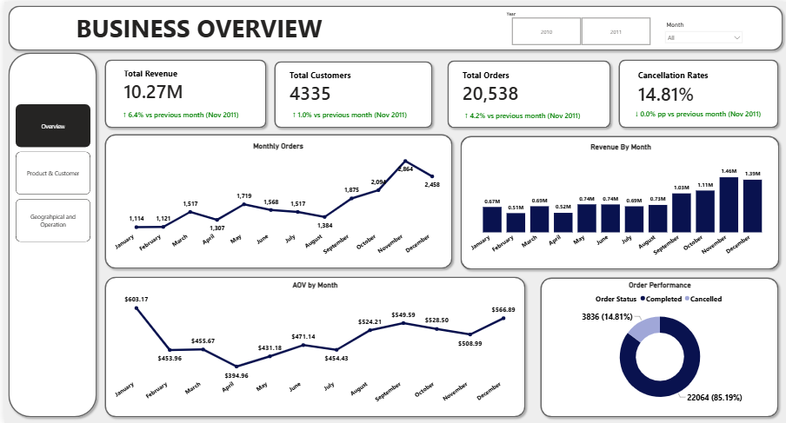

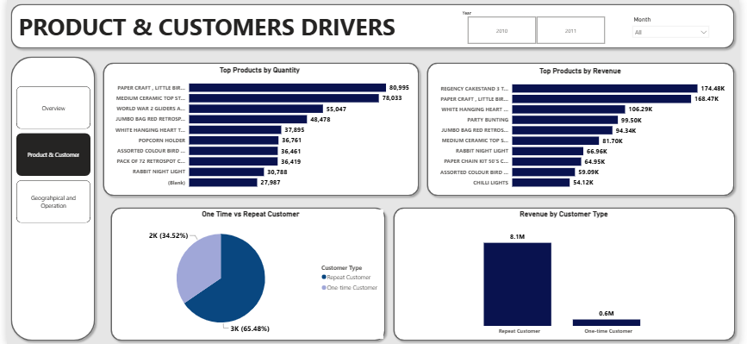
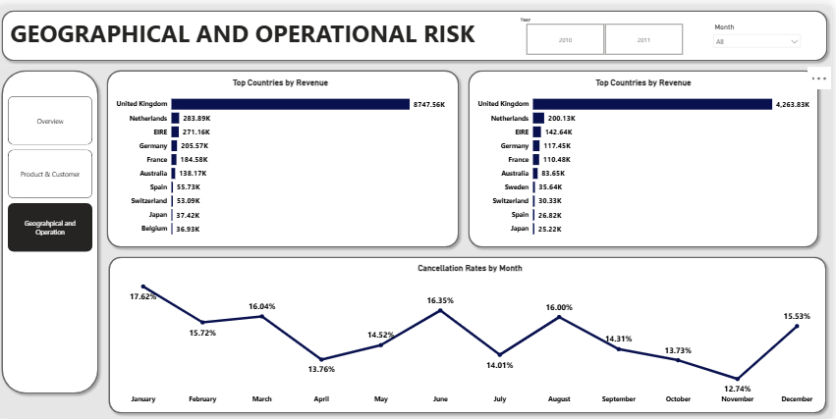
Recommendation
The analysis indicates several areas that can be monitored based on the observed patterns.
- The business should monitor monthly order volume alongside average order value to identify whether revenue changes are primarily driven by changes in order volume or customer spending per order.
- Product performance can also be tracked using both revenue and quantity sold, since products with high sales volume are not necessarily the same products generating the highest revenue.
- Customer performance should continue to be monitored by distinguishing repeat customers from one-time customers and assessing their contribution to revenue.
- The concentration of revenue in the United Kingdom can also be monitored alongside performance in other countries.
- Finally, the cancellation rate and its monthly variation should be monitored to identify periods with relatively higher cancellation activity.

Conclusion
The analysis provides an overview of the online retail business across time, products, customers, geography, and order status. The business generated 10.27M in total revenue from 20,538 orders and 4,335 customers, with noticeable variation in monthly revenue and order activity. Product performance also differed when measured by revenue and quantity sold, while repeat customers represented a substantial part of the customer base. Revenue was heavily concentrated in the United Kingdom, and cancellations accounted for 14.81% of orders. Overall, the analysis provides a structured view of the business's performance and highlights the areas that can be monitored further.

Workflow
Raw Dataset → Data Cleaning → Feature Engineering → SQL Analysis → Power BI Dashboard → Business Insights

